Welcome to the world of BASH
bash is an acronym that stands for borne again shell
bash was designed to replace the much simpler “Bourne Shell” or sh
A shell is a terminal. Here is an example: 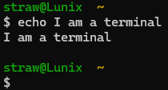
The terminal or shell is distinct from the desktop. Below is a desktop GUI:
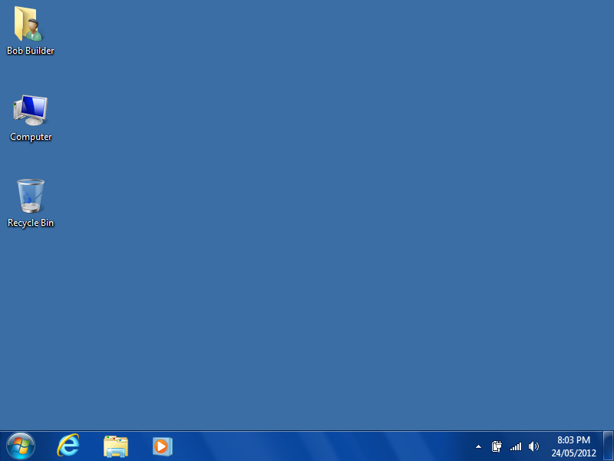 or 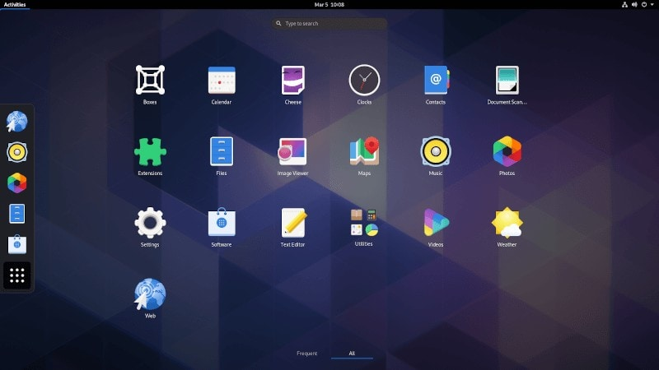
Note: bash is installed by default on almost every Linux operating system, in windows it must be installed because windows utilizes a different terminal language known as Power Shell by default.
- Making your first file
- To begin shattering the veil cast over our eyes by the comforting desktop interface let us open a terminal:
- For Windows see the bash installation guide for windows here.
On Linux (Debian based) open the terminal with the keyboard shortcut Ctrl + Alt + t
- Now that the terminal is open type the command ‘help’ and press enter/return. Here you will see a large number of commands and helpful hints for learning them. Now type ‘clear’ and press enter/return.
- Now type the command ‘ls’ and press enter. “ls” stands for “list”. You should see many files and some directories too. Type ‘clear’ and press enter then type ‘ls -l’ and press enter. Ls -l means “long list” or “list long” as you can see it is longer and contains much more info than the ‘ls’ command did.
- Type the command ‘touch file1’ and press enter. You’ve just created a file. Enter the command ‘ls’ again. You should see a file named file1. Type cat file1. You should see nothing shown in the terminal: That is because “cat” lists all the text information contained in a file. Enter the ‘clear command’
- Enter the command ‘vim file1’
- If you don’t have vim installed on a Debian based operating system such as Ubuntu enter ‘sudo apt install vim’ and try again.
Press ‘i’ you should now be in insert mode. Now type out a statement such as “Hello World!” From here, press the escape key esc then press shift and hit the colon key then let go of shift and type wq. “wq” stands for write and then quit. Now type the command ‘cat file1’.
II. Navigating Directory Hierarchies
- Enter the command ‘cp file1 mytext1’. “cp” stands for copy. Enter ‘ls’ to see the results. Enter the command ‘cat mytext1’, notice it is the same as file1.
- Enter the command ‘mkdir Directory1’: enter ‘ls’ to see the results. “mkdir” stands for make directory. Next type ‘cd Directory1’: “cd” stands for “change directory”. Enter ‘ls’ and notice that this new directory is empty. Further, your terminal should look something like this now: 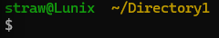 The ~ means “home directory” you are now in the subdirectory “Directory1”. Enter ‘mkdir subDirectory1’ then ‘cd subDirectory1’. Now your terminal should look a little different:
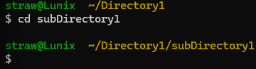
Let’s read what this means in human English. Your current command line is located within the “subDirectory” folder which is contained within the “Directory1” folder which itself is located within the home directory like so: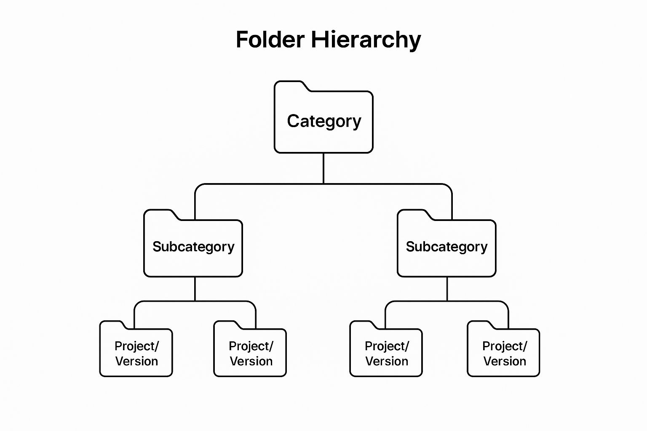
- Now enter ‘cd ..’ You just left subDirectory1 and entered Directory1. Now make a folder hierarchy like the image above containing two subdirectories and two projects per subfolder. Example commands:
mkdir ~/Directory1/subDirectory2
mkdir ~/Directory1/subDirectory1/Project1
mkdir ~/Directory1/subDirectory1/Project2
etc.

- After completing this navigate to Directory1 using the ‘cd ..’ command or ‘cd; cd /Directory1’
- to witness the glory of what you have just accomplished type the command ‘ls -R’ If you’ve done everything correctly your terminal should display something like the following image:
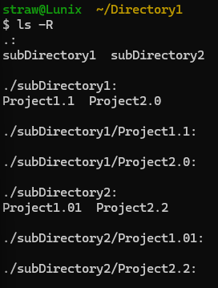
Here the “-R” in the previous ‘ls -R’ command means recurse. Recurse means if there are any directories inside the current directory display not only them, but their contents and any subdirectories and their contents.
5. Now enter ‘cd /’ “/” is the root directory. In almost every filesystem, the very top of the entire file and directory hierarchy is represented by a slash / and called the root of the hierarchy. The root holds everything in the entire hierarchy from system files to the tree you just made. Now enter ’ls -l’ these are the primary directories of the hierarchy. In linux this is typically listed as follows:
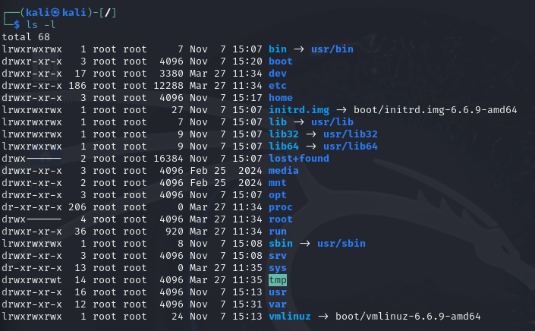
- Notice the home directory; this is where user information is stored upon entering you will typically see the home directory represented by “~” of each user.
- The boot directory contains all the files that the operating system uses to start and launch the user interface.
- bin contains commands that linux can use. This is where things like ‘ls’, ‘cd’, ‘cat’ et al. are defined and stored.
- sbin is the same but it defines the commands that only the super user has access to.
- We will conclude with tmp but suffice it to say, each folder has a justification as to why it is located just underneath root. “tmp” stands for temp or temporary. Effectively, this is where the operating system stores files that it will only briefly used. After a set time or a restart, this folder will delete all contents.
6. Finally, let’s go over how to rename files and directories. Navigate to your user’s home directory. From here rename the Directory1 directory to something memorable and easily identifiable like, “bash_projects” using the command:
‘mv ./Directory1 ./YOURDIRECTORYNAME’
The “mv” command means “move”. This is in fact how computers rename files; They make a copy of the old file with a new name and delete the old one. They don’t actually “rename” the old file.

Challenges: complete all challenges to pass
- Within three separate project version folders, make new text files containing something that you would want people to know about you. Alternatively, you can write code or a treatise if that pleases you. You may use the previously created directory tree.
- Make a folder named “debian” within the /mnt directory so it looks like /mnt/debian. Within that folder make a file that contains a brief description about what the /mnt directory is typically used for. Feel free to look up the answer.
- Copy all three of the files you completed in step one into the directory you renamed. Now rename these files exactly with the following format. File 1: Examplefile1, File2: Examplefile2, File3:Example_file_III
- Finally, copy one of these example files into the /mnt/debian
